LEARNING ACTIVITIES AND RESOURCES
Term Paper Learning Assignment
For this assignment, you will be required to write an academic paper that includes six elements: 1) an introduction, 2) synopsis of two documentary films, 3) description and analysis of one evidence-based research-paper, 4) description of the clinical phenomenon of the condition, 5) prioritization and discussion of three nursing interventions, and 6) a personal reflection.
Instructions: Select a diagnosis of interest studied in this course. Go outside the textbook to research the condition. Write an 8-12-page paper (excluding title and reference pages) using APA format (7th edition) and meeting the following criteria:
- A synopsis of the selected documentary films (not to exceed three pages for both documentaries). Write enough to convey that you have watched the entire documentary. Documentaries selected need to have a production date on or after the year 2000 and be greater than 30 minutes in length. Review the credits at the end of the documentary before watching the film to find the production date. You may find documentaries on YouTube or other resources of your choice. Additionally, Kanopy streaming service provided by LAHC library has many documentaries in its database. (http://lahc.kanopystreaming.com/restricted?destination=frontpage). Note: the production date of the documentary is not the date it was uploaded to YouTube.
- A description of the clinical presentation (signs/symptoms) and/or a description of the phenomenon. Go outside the book and use your own clinical observations. Review the categories assessed in a mental status examination. Describe how a patient with this disorder presents clinically (use your mental status assessment as a guide and include descriptions of possible appearance, behavior, affect, mood, speech, thought process, thought content, cognition, etc.). Give examples in these categories. If you select a disorder where the patient is not necessarily seen in the hospital setting, describe the phenomenon and specifics about the topic. For example, in the case of sexual assault or intimate partner violence, describe the perpetrator, victim and theory describing the phenomenon. This section is not asking for etiology or pathophysiology.
- Discuss three priority nursing interventions. Describe how you would use these clinically and the rationale for their use. Think about what the most important considerations would be and prioritize these in order.

- A discussion of one evidence-based research paper that presents some of the newest research in the field (published within the last five years). It must be a scientific study published in a peer reviewed journal where data was collected and analyzed by the researchers.
  - Describe the study and the research findings.
  - Identify main design of the study. Select a study design that would fit in the “primary studies” design from the pyramid below. Do not select a “meta-analysis” or “systematic-review” or any type of “review” article.
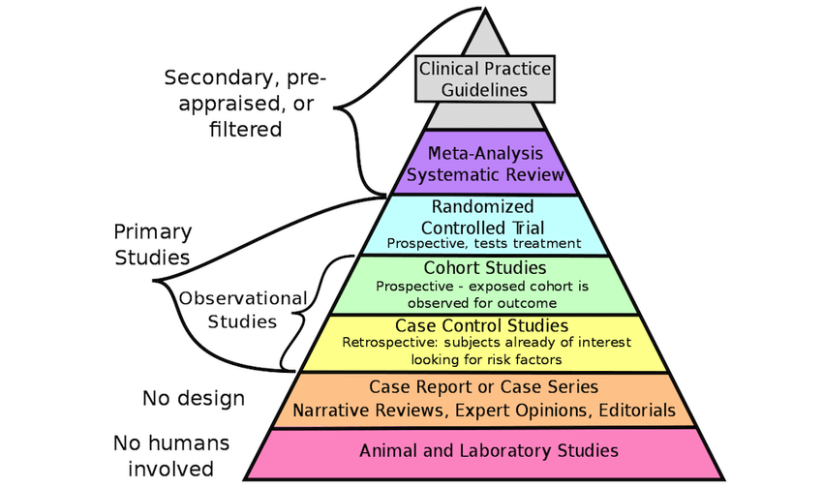

  - Describe your analysis of study design. Were enough people included in the sample? If there were a small number of people studied, why do you think that was? What is the importance of the findings and how the findings can be used. Can the findings be generalized to the larger population or is it limited in some way? Were the findings replicated or do they need to be replicated? If the findings were not positive, what does that mean? This is not an all-inclusive list but can get you started in the right direction.
- Additionally, Research articles follow a particular format. Look for:
    - A brief introduction will often include a review of the existing literature on the topic studied and explain the rationale of the author's study. This is important because it demonstrates that the authors are aware of existing studies and are planning to contribute to this existing body of research in a meaningful way (that is, they're not just doing what others have already done).
    - A methods section, where authors describe how they collected and analyzed data. Statistical analyses are included. This section is quite detailed, as it's important that other researchers be able to verify and/or replicate these methods.
    - A results section describes the outcomes of the data analysis. Charts and graphs illustrating the results are typically included.
    - In the discussion, authors will explain their interpretation of their results and theorize on their importance to existing and future research.
    - References or works cited are always included. These are the articles and books that the authors drew upon to plan their study and to support their discussion.
    - A “review article” is a secondary source...it is written about other articles and does not report original research of its own. Review articles are very important, as they draw upon the articles that they review to suggest new research directions, to strengthen support for existing theories and/or identify patterns among existing research studies. For student researchers, review articles provide a great overview of the existing literature on a topic. If you find a literature review that fits your topic, take a look at its references/works cited list for leads on other relevant articles and books! (source Dr. Tariq Sheakh: https://www.researchgate.net/post/What_is_the_difference_between_Research_Paper_Research_Article_Review_Paper_Review_Article1/50965497e39d5eb35c000007/citation/download)

- A discussion of your thoughts or feelings in one or more paragraph(s) about what you watched written in the first person (i.e., I learned… I felt… I can use this information to… etc.). Describe how you can use this information in your professional capacity and personal life. Describe any stigma previously held and if researching this condition changed your view in any way.

After you are satisfied with your final version of your paper, submit one copy to turnitin.com and a second copy to mooreev@lahc.edu in word format. Instructions for submission to Turn It In are located at the end of this section.

You will be required to submit your paper In APA format according to the 7th edition. Recommended resources for understanding and applying APA style can be found here:
- https://apastyle.apa.org/instructional-aids
- https://owl.purdue.edu/owl/research_and_citation/apa_style/apa_style_introduction.html
APA Student Papers include the following: title page, introduction, body of paper, and reference page. A key challenge for this assignment will be the development of your skill in APA style referencing and crediting researchers from the primary source. It is your responsibility to follow statistics and data to the primary (original) source if at all possible. You need to have a clear understanding of the term secondary reference or indirect source and make every effort to go to the primary source in your research. (See- https://apastyle.apa.org/style-grammar-guidelines/citations/secondary-sources). Another common error is for a student to find a “review article” where an expert reviews current research in the field and cites the review author as the researcher. Additionally, you should not cite your textbook chapter authors or any author of a review article for statistics/data without attempting to go to the original source. If the original source cannot be accessed, you will need to use the indirect/secondary reference style to source this material.
Understand what you are considering for inclusion in your paper. Ask yourself, is this the research article or am I reading a review by an expert of many different studies? A research article is required for this paper. Reviews are good for increased understanding of your subject but not to be used as your research article. Another type of research article is a meta-analysis, which is allowed for use as your research article. Additionally, ask yourself, is this an informational website (such as WebMD, Wikipedia or Mayo clinic)? These sites are good for increased understanding but not for citing research. These sites are acceptable to increase your knowledge on the subject but do not fulfill the requirement for research-based articles. You are expected to go outside the book to increase your understanding of the chosen condition. Do not simply summarize what is in the book but add to what you find in the textbook. Lastly, do not use a prior paper submitted to this course as a model for your paper. Plagiarism includes copying the organizational style of another paper, the references and/or the order of the sentences even if you change the wording. For additional information on Plagiarism, please visit: https://apastyle.apa.org/style-grammar-guidelines/citations/plagiarism
You must always use the current edition of the textbook required for this course if you plan to use this source as a reference for your paper, however use of the textbook should be minimal as the requirement for this assignment is to research the condition outside the textbook.
There will be 40 points possible for the paper with 10 of the points assigned to APA formatting. Please review the grading rubric to guide you in writing your paper. You should look at your paper after completion and be satisfied that you have described the condition fully. Be sure to include a clinical description of the condition as well as signs and symptoms. Use references appropriately and be aware they will be checked. Possible sites to increase your knowledge beyond the textbook. or to find research include: SAMSHA, NIMH, NIDA, NAMI, Medscape (Psychiatry & Mental Health Journals), Psych Central, American Psychological Association. For research articles, some possibilities include but are not limited to:
LAHC Library -http://libguides.lahc.edu/library
For assistance from an LAHC librarian, please visit:
https://lahc.libcal.com/appointments
PubMed - http://www.ncbi.nlm.nih.gov/pubmed
National Institute of Mental Health https://www.nimh.nih.gov/
Evidence-Based Mental Health (open access) - https://bmjopen.bmj.com/
Brain & Behavior Research Foundation - https://www.bbrfoundation.org/

GRADING RUBRIC FOR AV PAPER
Element | Points Possible  40 | Your Score
Synopsis – clear brief presentation in an organized manner | 4
Clinical presentation of the condition | 8
Nursing interventions with rationale | 5
Personal thoughts and feelings | 3
Meaningful discussion of research-based study | 10
APA Style (7th edition) including grammar | 10
Total | 40

